EECE 5554 – Robotics Sensing and Navigation

LAB 5 – REPORT

**1. Calibration**

Note:- All images are taken with Oneplus 5T with 1x zoom. All the .m files are included and pushed to github.

* 1. **Images used for calibration**

This part of the lab is meant to obtain the calibration parameters of the camera used because of distortions caused by the camera lenses. Modern cameras come with inbuilt calibration that corrects the distortions, still we will try calibrating the camera externally using Caltech Calibration toolbox to get the reprojection error and to see if trying to correct the image makes it distorted or over calibrate it. Here we are using 25 images of the calibration pattern taken from different angles.

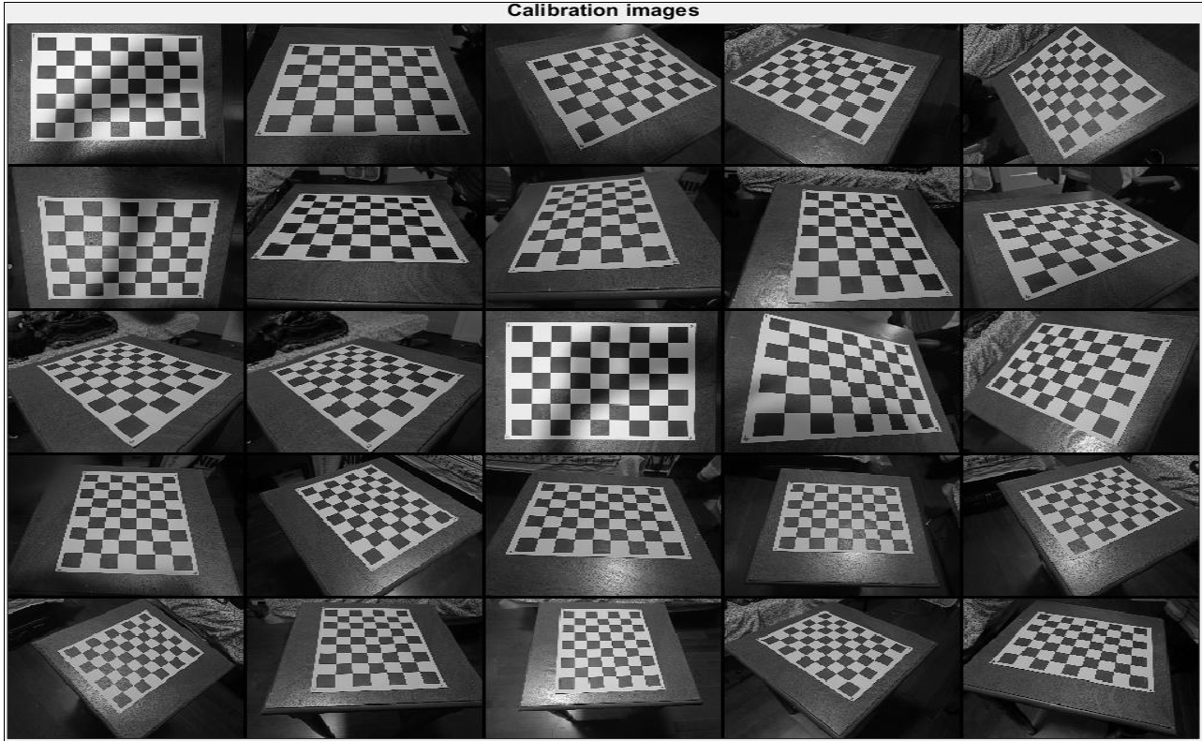

Fig 1.1 Images used for calibration

* 1. **Calibration parameters**

To find the reprojection errors and calibration parameters we need to extract the corners from the checkerboard image by using **“Extract Grid Corners”** option from the calibration toolbox. To extract all corners from 25 checkerboard images the order of corners is indicated on the extremes of the edge of the pattern as 1,2,3,4 as seen in Fig 1.2. In case if the predicted corners are not close to the actual corners, we can provide an initial guess manually for the lens distortion coefficient. Fig 1.3 has all the calibration parameters used. The following is the units used for the parametes

|  |  |
| --- | --- |
| **Parameters** | **Units** |
| Focal length | pixels |
| Distortion | Unit less |
| Principle Point | pixels |
| Alpha_c | pixels |
| Pixel error | pixels |

Table 1 – Units of parameters used

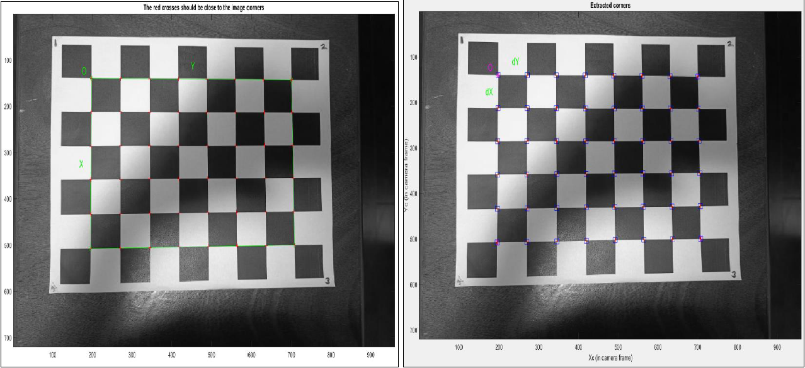

Fig 1.2 Left – red plus are the corners detected, Right – Blue square indicated the limits of corner finder window

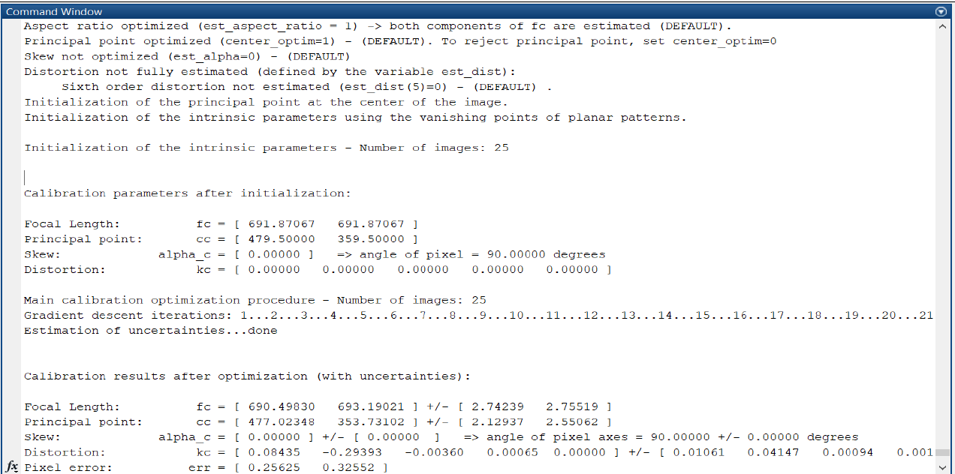

Fig 1.3 Calibration Parameters

* 1. **Reprojection pixel error**

After first calibration the pixel error is [0.25625, 0.32552] pixels. Using the intrinsic and extrinsic parameters, we generate the reprojections of the grids onto the original images using the “**reproject on images”** option.

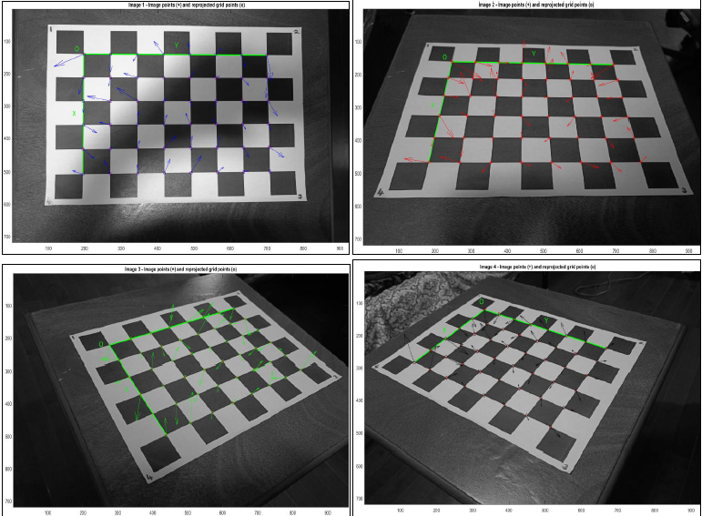

Fig 1.4 Reprojection error on image dataset

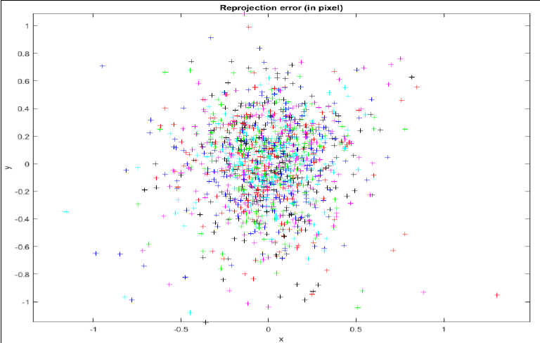

Fig 1. 5 Reprojection pixel error of all 25 images

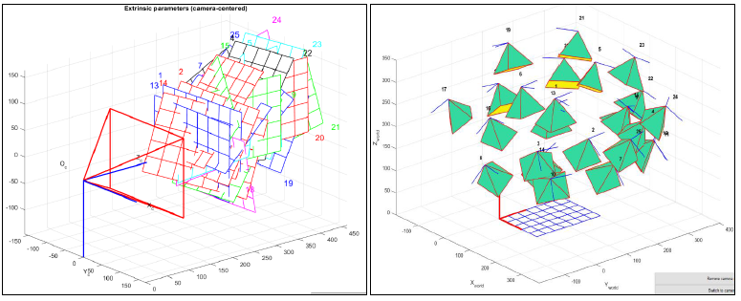

Fig 1. 6 Left - Relative positions of the grids with respect to the camera,

Right - Extrinsic parameters with respect to the world centred view

From Fig 1.5 we can see that the reprojection error is very large. This is because the corners of few images are not extracted correctly. To solve this, we can use the **“Recomp Corners”** option to recalibrate the image. The corners that are causing the errors can be identified from Fig 1.7. The blue pluses are the badly predicted corners. The information about such corner like the image it belongs to, the exact corner and its coordinate can be viewed in MATLAB.

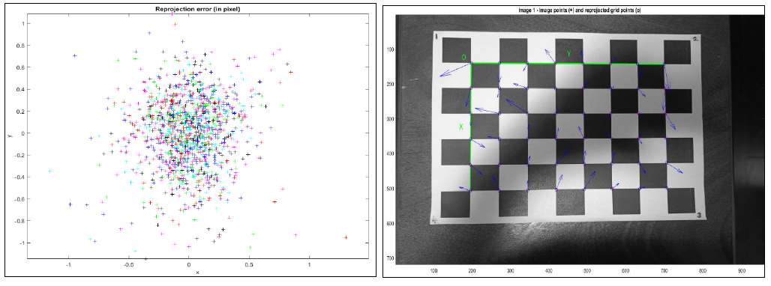

Fig 1. 7 Left - Top left corner causes the error, Right - Marked corner caused the error

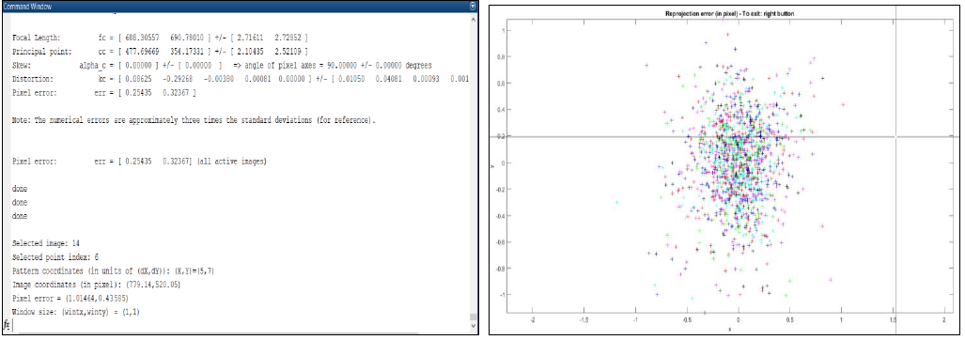

Fig 1. 8 Left - Recalibrated parameters, Right - Representation of reprojection pixel error after multiple calibration

From Fig 1.8 after multiple calibration the iterations are reduced from 21 to 14. The steps involved in calibration are as follows: **Recomp. Corners -> selected the custom size of the window for the individual images -> Calibration -> Analyse error -> observed which corner is adding error by clicking on a particular corner on the reprojection error figure ->supress the image -> repeat.** The final reprojection pixel error we obtained is [0.25435 0.32367] pixels.

* 1. **Images before and after calibration**

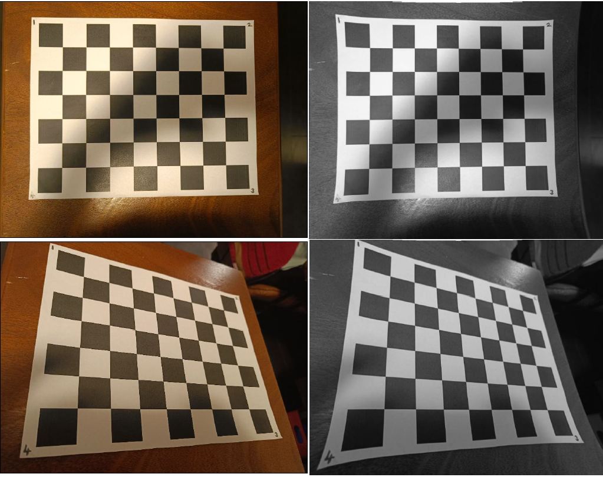

Fig 1. 9 Left - Original Images, Right - Corrected Images

As we can see from Fig 1.9, the image after correction are more distorted than the original images. This proves that the mobile phone already corrects the raw image and provides the undistorted image for us to view. Even finding calibration parameters for it and trying to correct the images from it causes more distortion. Hence, from here on we are using the original images that we get from the mobile phone’s camera directly for the lab and used for creating a panoramic image.

**2. LSC Mosaic**

**2.1 LSC image set**

Six images of Mural on the “Latino Student Centre” on Forsyth Street are taken from across the street for part 2 of the lab. This is preferred because Harris detector detects 2D surface features better than 3D. Fig 2.1 shows the image data set used for stitching and creating a panoramic image.

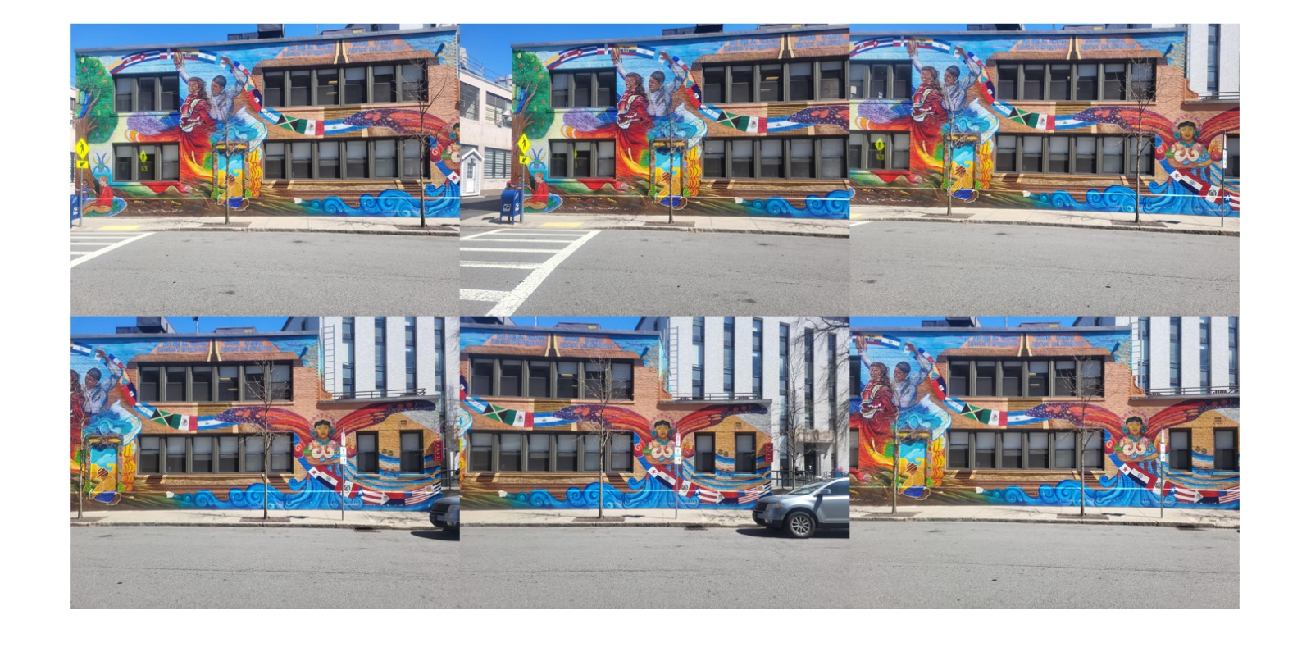

Fig 2. 1 Image data set of LSC mural

**2.2 Distribution of Harris corners**

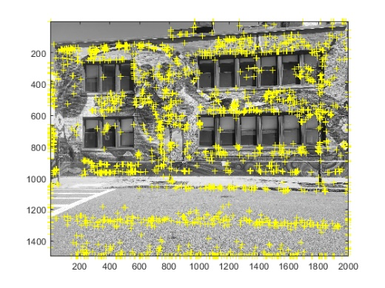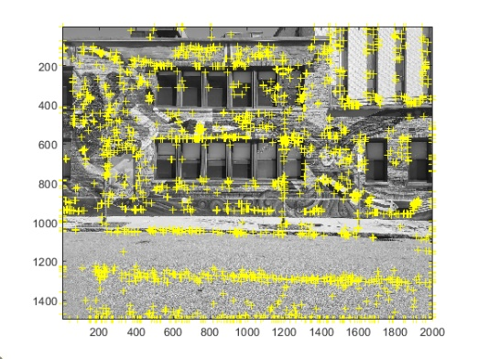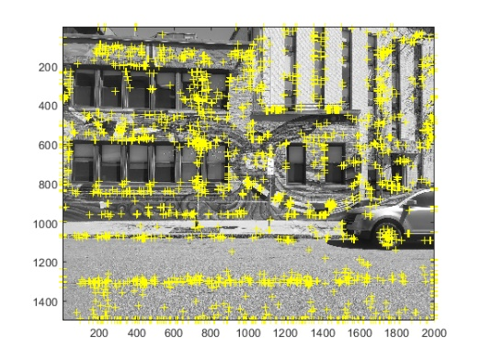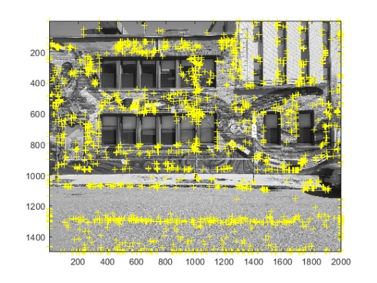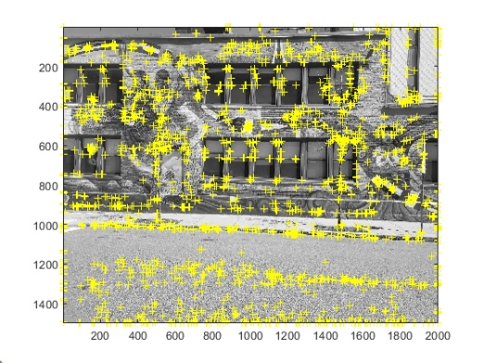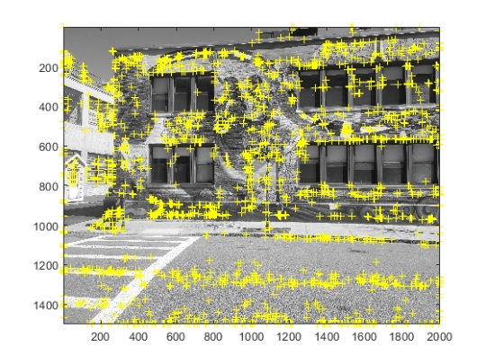

Fig 2. 2 Distribtuion of features detected by Harris Corners in the image dataset

**2.3 Final Mosaic**

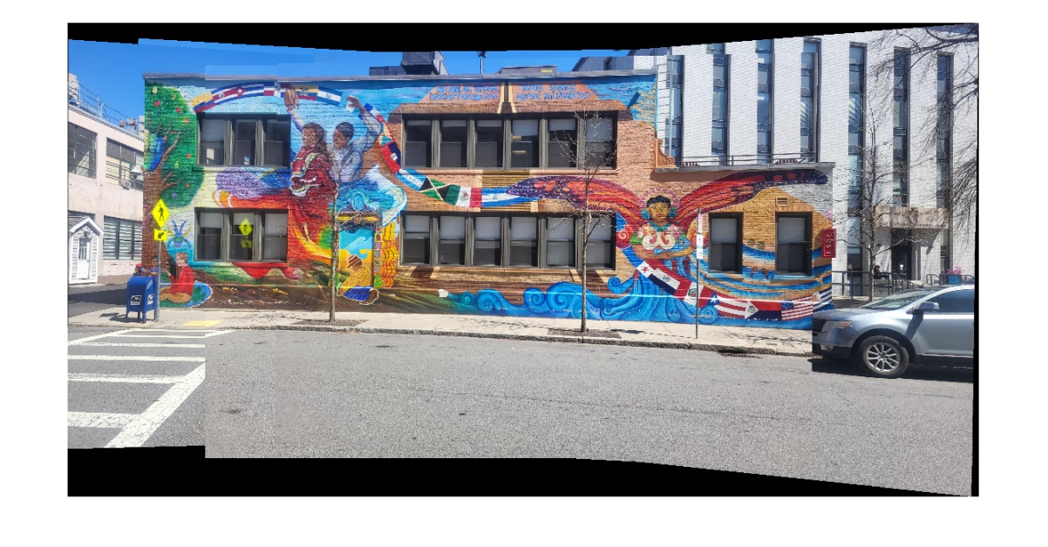

Fig 2. 3 Final image after stitching

**2.4 Discussion of adjustment/intermediate image steps taken**

The main goal of adjusting the parameters is to distribute Harris feature points uniformly across all the images. By selecting a poor threshold, feature points may accumulate in a certain region leading to ignorance of other features. The following values are used to get uniform distribution of feature points. By selecting tile size more distorted the stitching and selected less value caused the feature points to accumulate. Other parameters are set to default value.

|  |  |
| --- | --- |
| No. of interested points | Tile Size |
| 3000 | [8 8] |

**3. Cinder Brick Wall**

**3.1 Image set**

Six images of cinder brick wall taken from different position is used for this part of the lab.

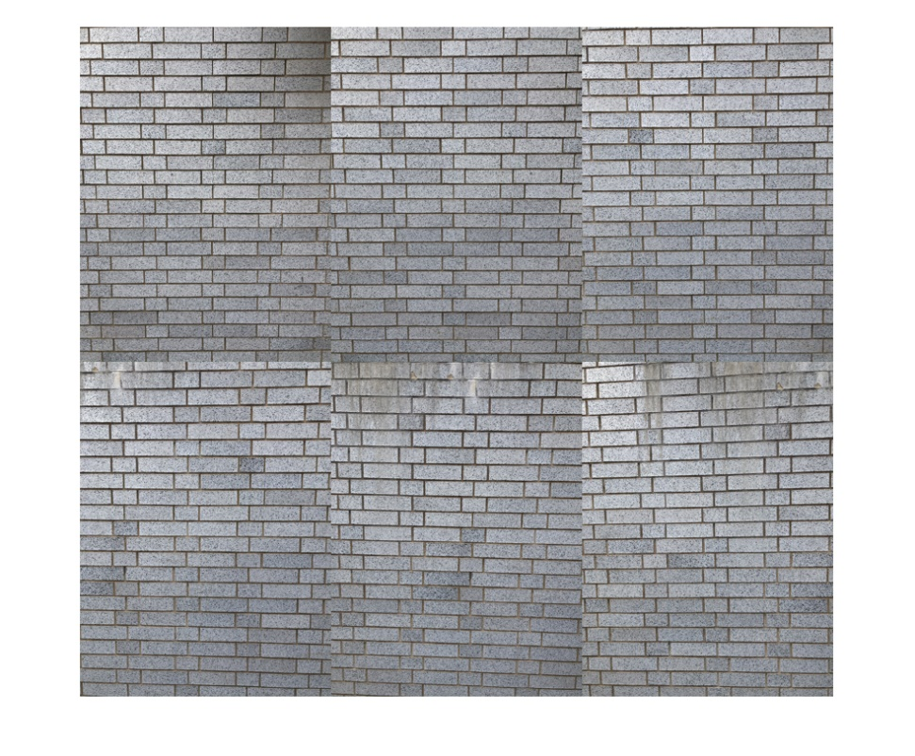

Fig 3. 1 Image data set used for part 3

**3.2 Harris Corners**

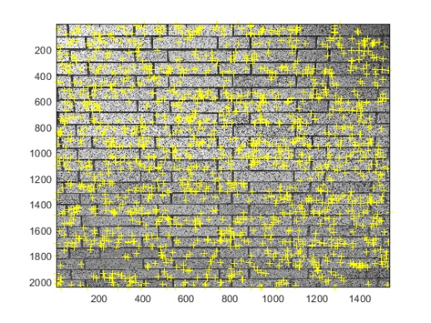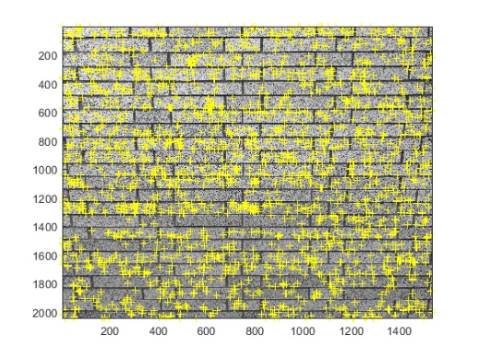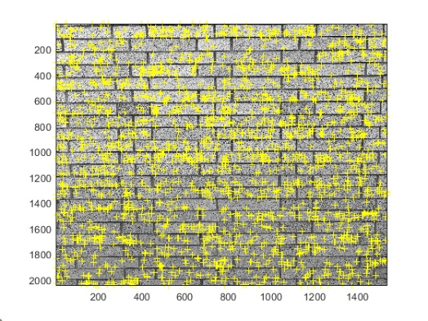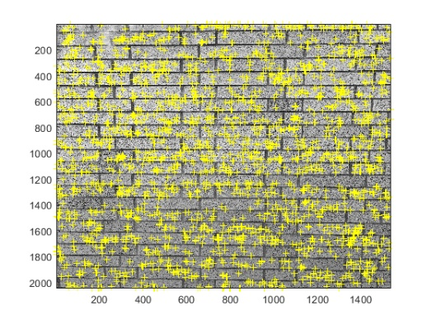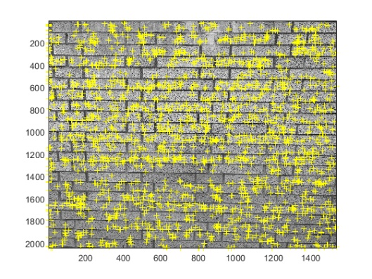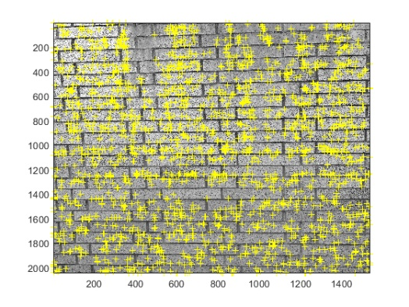

Fig 3. 2 Image set with detected feature points on brick wall

**3.3 Final Image**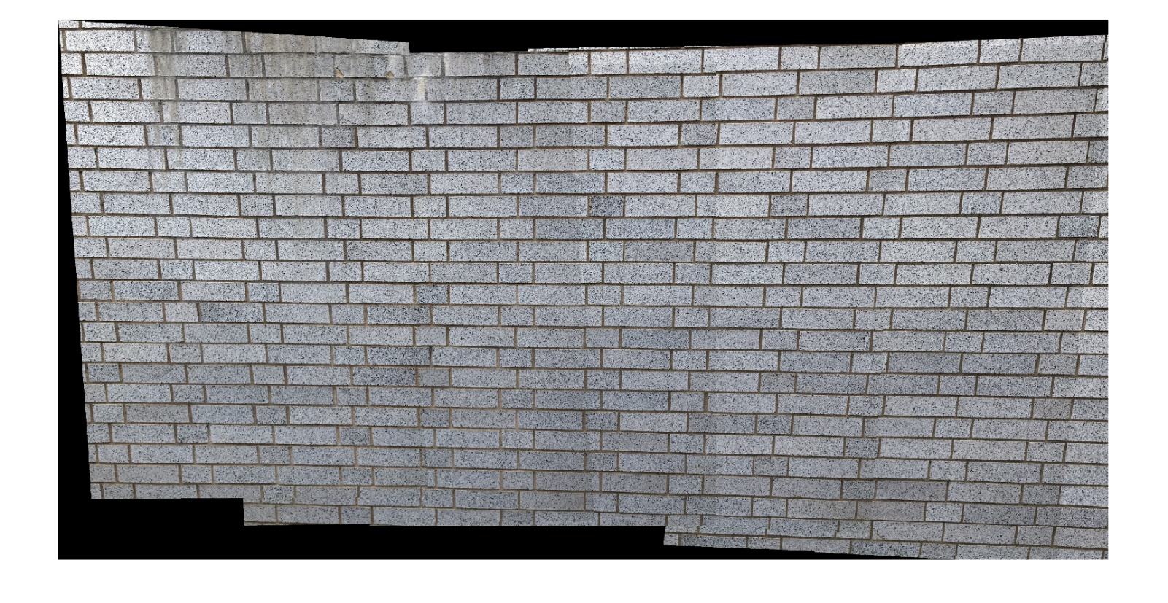

Fig 3. 3 Final stitched image of cinder brick wall

**3.4 Discussion of adjustment/intermediate image steps taken**

The following values are used to get uniform distribution of feature points. Interested points are set as 2000 because the images lack more feature hence reducing redundancy resulting in bad stitch and varying the tile size less or more either distorted the final image or created chose poor feature points. Other parameters are set to default value.

|  |  |
| --- | --- |
| No. of interested points | Tile Size |
| 2000 | [10 10] |

**4. Graffiti Mosaic 1**

**4.1 Initial Images with Harris Corners with 15% overlap**

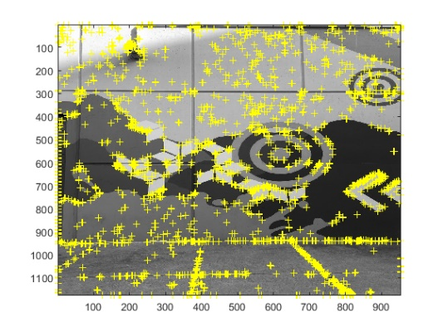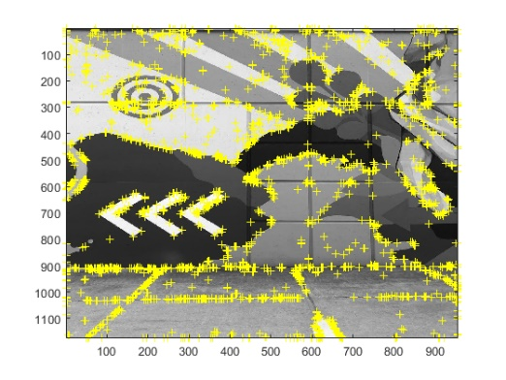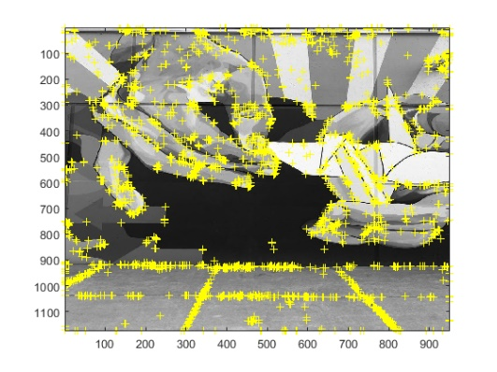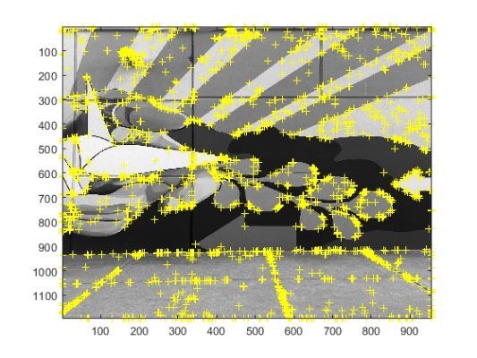

Fig 4. 1 Initial image data set used for part 4 with Harris corners with 15% overlap

**4.2** **1 Initial Images with Harris Corners with 50% overlap**

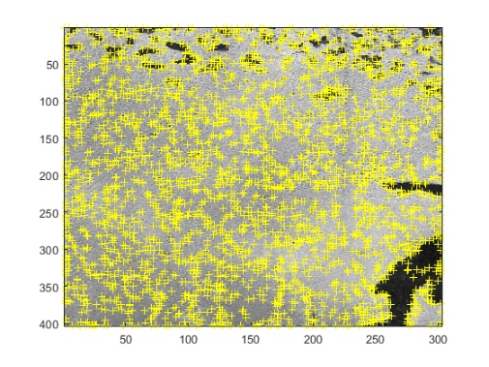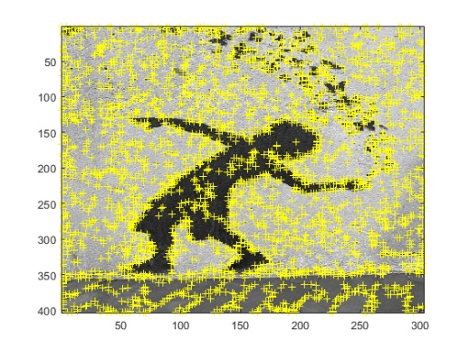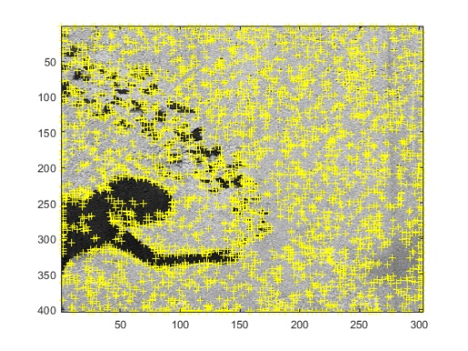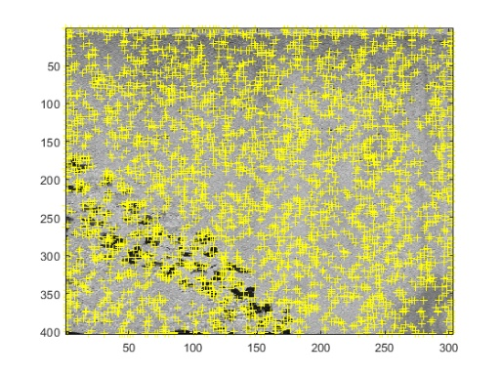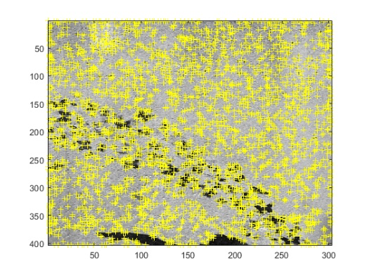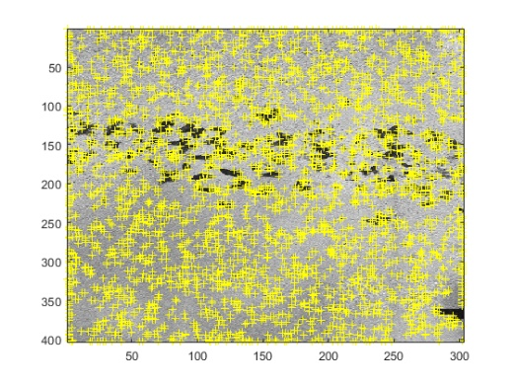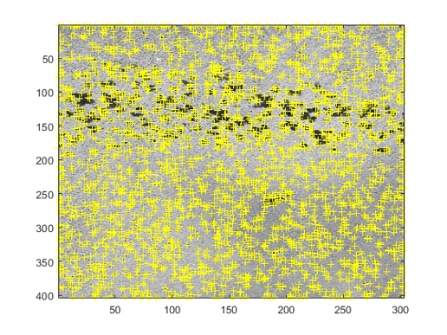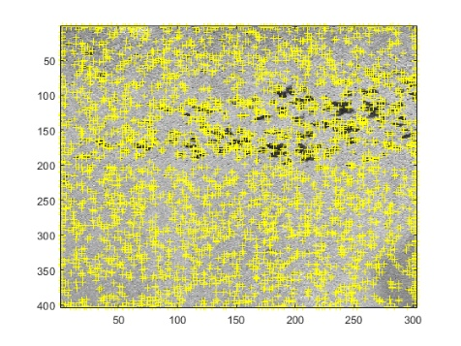

Fig 4. 2 Initial image data set used for part 4 with Harris corners with 50% overlap

4.3 Final Image

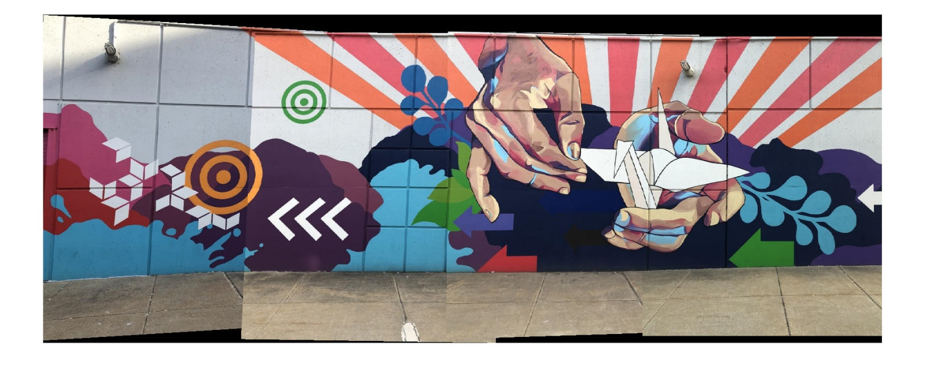

Fig 4. 3 Final Image of data set with 15% overlap

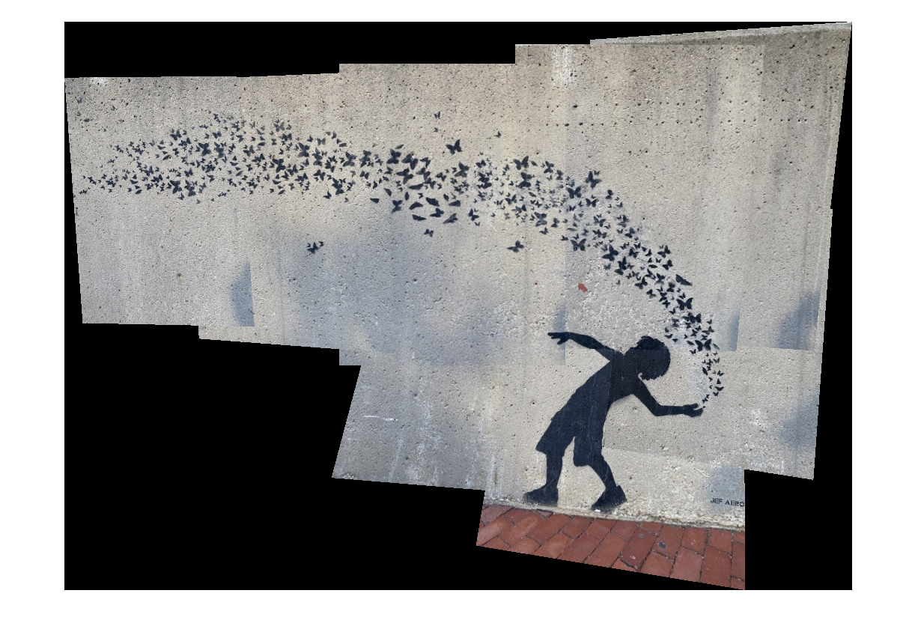

Fig 4. 4 Final image of data set with 50% overlap

**3.4 Discussion of adjustment/intermediate image steps taken**

The following values are used to get uniform distribution of feature points. Interested points are set as 2000 because the images lack more feature hence reducing redundancy resulting in bad stitch and varying the tile size less or more either distorted the final image or created chose poor feature points.

For data set with 15% overlap

|  |  |
| --- | --- |
| No. of interested points | Tile Size |
| 2000 | [5,5] |

For data set with 50% overlap

|  |  |
| --- | --- |
| No. of interested points | Tile Size |
| 3000 | [10,10] |

Other parameters are set to default value.

**3.4 Discussion of performance of 15% vs 50%**

The number of images used for 15% overlap is less compared to 50% overlap. Hence, for the first caser the number of distinct features detected by Harris corner are less than 50%. Hence the overlapping is not as good as the other case as seen in Fig 4.2 where the left most image is stacked in contrast to proper stitching. In contrast to 50% overlapping where the number of images used are more. This results in more distinct feature being detected. Hence a proper stitching is seen even though we can see the original images were not taken from same distance or zoom making the stitched images to vary in size.

**All the MATLAB files are included and pushed to the GitHub repository.**